Vignesh A S (569604)

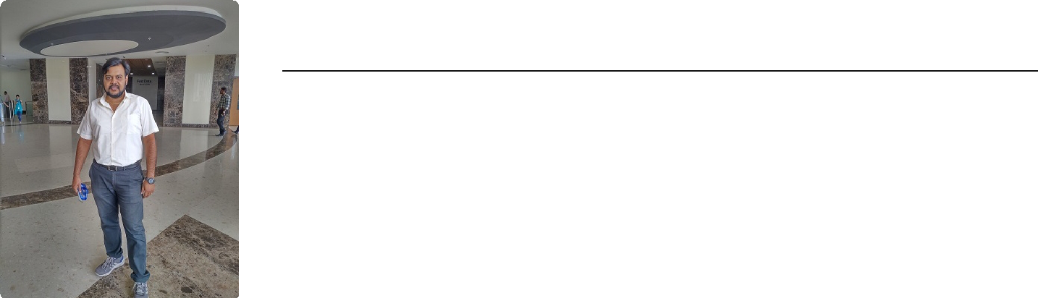

**E-mail:** [*vignesh.as@cognizant.com*](mailto:vignesh.as@cognizant.com)

**Code fights:** [*https://app.codesignal.com/profile/vickey_s*](https://app.codesignal.com/profile/vickey_s)

**GitHub:** [*https://github.com/asvignesh-qae*](https://github.com/asvignesh-qae)

**Quora:** [*https://quora.com/profile/Vickey-Sujey*](https://quora.com/profile/Vickey-Sujey)

**LinkedIn:** [*https://linkedin.com/in/vignesh-ambalam-suresh-55909143*](https://linkedin.com/in/vignesh-ambalam-suresh-55909143)

**Mobile:** +91 8144474445

PROFILE **QA Specialist/ Automation Test Engineer**

ACHIVEMENTS

SKILLS

**Over 7.5 years of experience in software testing, highly skilled in Selenium with Java, key Skills - Highly creative, go-getter and hardworking achiever. Succeeded in getting the automation project via POC, by problem solving, mentoring have anchored the automation project.**

Unstoppable Badge (01/2020)

[*https://app.codesignal.com/profile/vickey_s/badges*](https://app.codesignal.com/profile/vickey_s/badges)

Got this Badge for solving 100+ real time problems on Code Fights.



Rise to the Challenge Badge (12/2019)

[*https://app.codesignal.com/profile/vickey_s/badges*](https://app.codesignal.com/profile/vickey_s/badges)

Got this Badge for solving 50+ Daily Challenges on Code Fights.



POM - Pillar of the Month (03/2019)

[*https://qeawow.cognizant.com/*](https://qeawow.cognizant.com/)

Honoured for leading and anchored the automation project



Most Valued Team Player (06/2019)

*Cognizant Technology Solutions*

Honoured for the significant contribution for QA – Automation track from McDonald’s CTO.

**Programming Language:** Core Java, Basics of Python.



**Tools used:** Selenium Web Driver 3.6, IDE, Grid, TestNG 6.8, Putty, CA LISA, SOAP UI, Protractor.



**IDE:** Eclipse Oxygen, Photon.



**Framework:** Hybrid & TestNG



**Repository:** TFS



**Continuous Integration:** Azure Devops



**Defect Tracking Tools:** HP ALM & JIRA.



**Databases:** SQL Developer.



**Functional Testing:** SDLC, STLC & Bug Life cycle.



**Operating Systems:** Windows variants

WORK

EXPERIENCE

[Cognizant Technology Solutions](https://www.cognizant.com/) May 2016 — Present

Associate

**Role & Responsibilities – Automation Test Lead**

Developing test plan, test strategy, business scenarios (L0 scenarios).



Played the role of Test Lead from Offshore.



Groomed the Team of 4 fresher’s and anchored the Test Automation.



Designed the proof of Concepts for the Tools evaluation.



Followed Traceability matrix to cover all the requirements in testing. Preparing and review of test scenarios, test cases, test execution reports, defect reports.



Involved in System Integration Testing (SIT), User Acceptance Testing (UAT)



and provided production support after implementation.

Involved in analysing system specifications, design, development and execution of test plans and test cases for manual and automation testing. Creating Wrapper Methods to enhance the existing framework.



Develop automation scripts for new enhancements using selenium web Driver with Java.



Design Object repository in the selenium framework using XPATH locators in POM.



Involved in creating and maintaining the Master Branch in TFS.



Involved in code merging activities and resolving the conflicts occurred during the code merge.



Preparation of Test Approach, Test Scenarios and Test cases from Functional Specifications.



Preparing Effort/Estimation and resource loading based on the timeline of the project.



Preparation of Daily Status Report and Weekly Status Report.



Resolved issues of team members and helped them to improve their performance.



* Leading and coordinating the team to complete the tasks on time.
* Having basic knowledge to configure and run the test in protractor.

Validated valid responses in SOAP UI for various sets of input from JSON file.



[Cap Gemini India Pvt Ltd](https://www.capgemini.com/in-en/) Mar2015 — Apr 2016

Associate Consultant

**Role & Responsibilities - Automation Test Analyst**

Experienced in GUI, Regression, Functional, UAT, Sanity and Automation testing. Functional and Regression testing with different framework like Hybrid, Data driven, Keyword driven, Page object model.



Expert in test scripts development and coordinating with development team to fix bugs.



Specialized in user requirement analysis, documenting test plans, executing of test cases to verify application functionality against business requirements, by using selenium web driver.



Experienced in using Azure Build tools to manage framework dependency jar files.



Having knowledge to configure with Azure Devops.



Extensive experience working with databases such as SQL and Oracle. Guiding new team members to acquire with knowledge on project, functional & technical.



Involved in delivery reports like DSR, WSR and execution dashboards.



Develop/Maintain web driver wrapper methods to enhance the existing framework.



Expert in De – bugging the Script during the script failure in IDE.



Have good knowledge in SQL and OOPS concepts.



Managed requirements traceability matrix (RTM) and status created activity diagrams and process flows.



Having hands on experience to defect management tools like ALM & JIRA. Writing Java Scripts using selenium web driver to automate the test scenarios of a web application in different browsers across various platforms.



Involved in writing the SQL query in the backend and validate the results such that the data is available in database tables.



Expert in writing Xpath expressions and other locators.



Expert in resolving conflicts due to code merge in Azure devops.



Designed and Anchored Proof of Concepts for the Tools evaluation.



Created Macros to minimize repetitive tasks in both MS Excel and Outlook.



[Tata Consultancy Services](https://www.tcs.com/) Jul 2012 — Feb 2015

Assistant Systems Engineer

**Role & Responsibilities - Functional Test Analyst**

Followed Traceability matrix to cover all the requirements in testing. Preparing and review of test scenarios, test cases, test execution reports, defect reports.



Involved in User Acceptance Testing (UAT) and provided production support after implementation.



Involved preparation of Test Cases by referring BRD/FSD.



Involved in weekly business call &amp; defect calls to give the detailed status of the work orders handled for that particular release.



Involved in writing the SQL query in the back end and validate the results such that the data are available in database tables.



Working and liaising with various stake holders in requirement gathering and analysis.



Preparing business requirement document and communicating to all the partners/stake holders.



Providing walkthrough on the BRD and participating in BRD calls/ Project weekly status calls.



Participating in the FSD walkthrough calls, mapping requirements with BRD



and maintaining traceability matrix to ensure the solution for the requirements are addressed.

Developing test plan, business scenarios (L0 scenarios).



Analysing system requirements provided in functional specification document and developed test scripts to test functionality.



Guaranteed that the business scenarios is aligned with real time business processes and scenarios to replicate model office environments. Execution of test scripts and defect management through Quality Centre 10.0.



CERTIFICATIONS [ISTQB Foundation Level](https://www.istqb.org/)

INTERESTS Cycling, Passionate about solving Sudoku, Photography & Avid writer on Quora.

EDUCATION B.E - Computer Science Aug 2007 — Mar 2011

[Anna University](https://www.annauniv.edu/)

3